Name : KEERTHANA R
Reg No : 411625104031
Department : CSE
Subject : JAVA (OOPS)
Batch : 3
Title : Vehicle Program Demonstrating Run-time Polymorphism using Interface
Aim
To design and implement a Java program that demonstrates run-time polymorphism using an interface and different vehicle classes.
Procedure
Step 1: Creating Interface
- An interface named Vehicle was created.
- It contains abstract methods:
  - start()
  - stop()
  - fuelCapacity()
  - maxfuelCapacity()
  - time()
- These methods define common behaviors for all vehicles.
Step 2: Implementing Classes
- A class Car implements the Vehicle interface and provides its own implementation of all methods.
- A class Bike implements the Vehicle interface and overrides all methods with bike-specific details.
- A class auto implements the Vehicle interface and defines auto-specific behaviors.
- A class taxi implements the Vehicle interface and defines taxi-specific behaviors.
Step 3: Designing the Main Class
- The Solution class contains the main() method.
- User input is taken using Scanner.
- Based on user choice:
  - Car object is created
  - Bike object is created
  - auto object is created
  - taxi object is created
- The object is referenced using the parent interface Vehicle.
- This demonstrates run-time polymorphism.
Step 4: Applying Object-Oriented Concepts
- Abstraction – Implemented using interface Vehicle.
- Polymorphism –
  - Run-time polymorphism achieved through method overriding.
- Encapsulation – Each vehicle class maintains its own behavior internally.
Step 5: Executing the Program
- The program displays a menu of vehicles.
- User selects a vehicle.
- The corresponding vehicle object is created.
- Methods are called using interface reference.
- Output is displayed based on selected vehicle.
Step 6: Testing
- Tested by entering values:
  - 1 (Car)
  - 2 (Bike)
  - 3 (auto)
  - 4 (taxi)
- Verified correct output for each vehicle.
- Confirmed run-time polymorphism works properly.
import java.io.*;
import java.util.*;
interface Vehicle{
void start();
void stop();
void fuelCapacity();
void maxfuelCapacity();
void time();

}
class Car implements Vehicle{
public void start(){
System.out.println("Starting the car...");
}
public void stop(){
System.out.println("The car has stopped.");
}
public void fuelCapacity(){
System.out.println("Fuel capacity: 50 liters.");
}
public void maxfuelCapacity(){
System.out.println("Max Fuel capacity: 60.");
}
public void time(){
System.out.println("Time per kilometer: 1 minute.");
}

}

class Bike implements Vehicle{
public void start(){
System.out.println("Starting the bike...");
}
public void stop(){
System.out.println("The bike has stopped.");
}
public void fuelCapacity(){
System.out.println("Fuel capacity: 15 liters.");
}
public void maxfuelCapacity(){
System.out.println("Max Fuel capacity: 20 liters.");
}
public void time(){
System.out.println("Time per kilometer: 2 minutes.");
}
}
class auto implements Vehicle{
public void start(){
System.out.println("Starting the auto...");
}
public void stop(){
System.out.println("The auto has stopped.");
}
public void fuelCapacity(){
System.out.println("Fuel capacity: 20 liters.");
}
public void maxfuelCapacity(){
System.out.println("Max Fuel capacity: 22 liters.");
}
public void time(){
System.out.println("Time per kilometer: 3 minutes.");
}

}
class taxi implements Vehicle{
public void start(){
System.out.println("Starting the taxi...");
}
public void stop(){
System.out.println("The taxi has stopped.");
}
public void fuelCapacity(){
System.out.println("Fuel capacity: 30 liters.");
}
public void maxfuelCapacity(){
System.out.println("Max Fuel capacity: 32 liters.");
}
public void time(){
System.out.println("Time per kilometer: 4 minutes.");
}

}

public class Solution {

public static void main(String[] args) {
/* Enter your code here. Read input from STDIN. Print output to STDOUT. Your class should be named Solution. */
Scanner scan = new Scanner(System.in);
System.out.println("Choose a vehicle:");
System.out.println("1. Car");
System.out.println("2. Bike");
System.out.println("3. auto");
System.out.println("4. taxi");

int c = scan.nextInt();
Vehicle v;
if(c == 1){
v = new Car();
}
else if (c == 2){
v = new Bike();
}

else if ( c == 3){
v = new auto();
}
else{
v = new taxi();
}
v.start();
v.fuelCapacity();
v.stop();
v.maxfuelCapacity();
v.time();

}
}
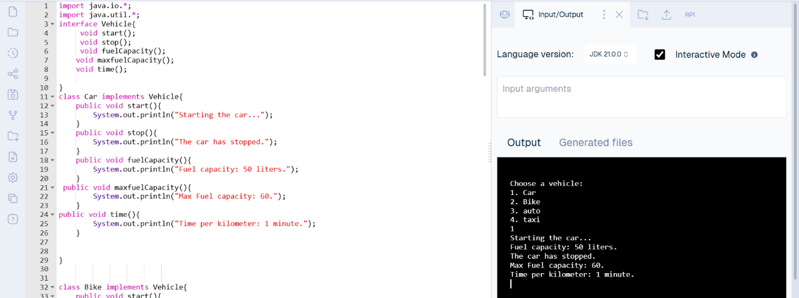

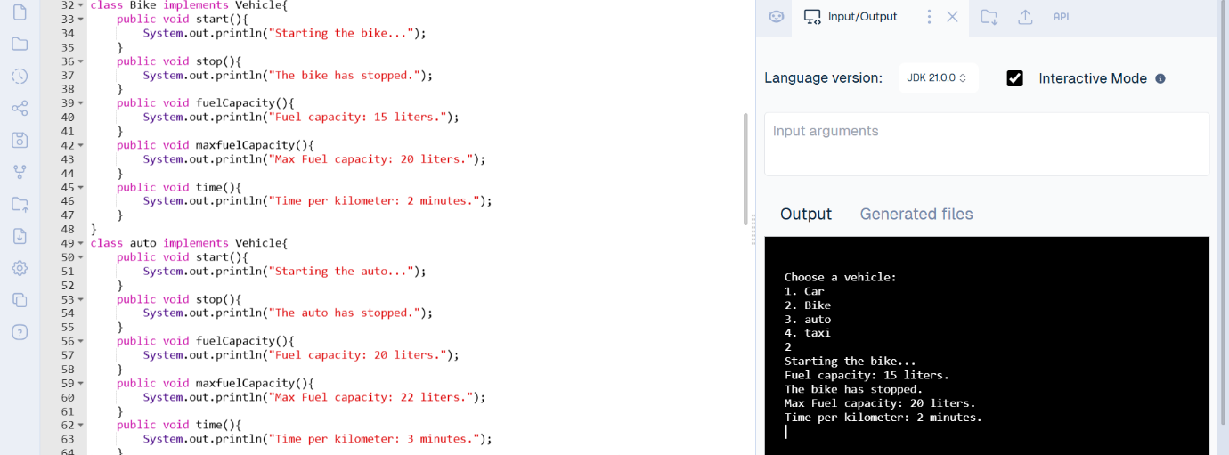
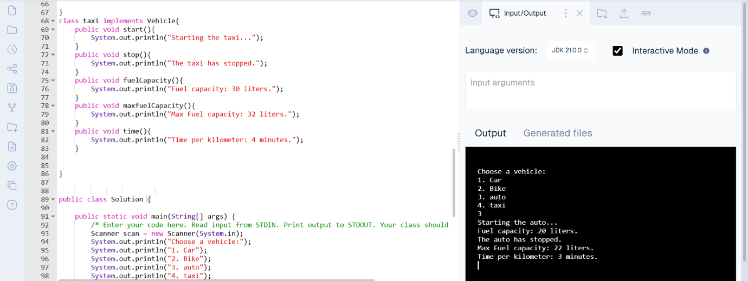
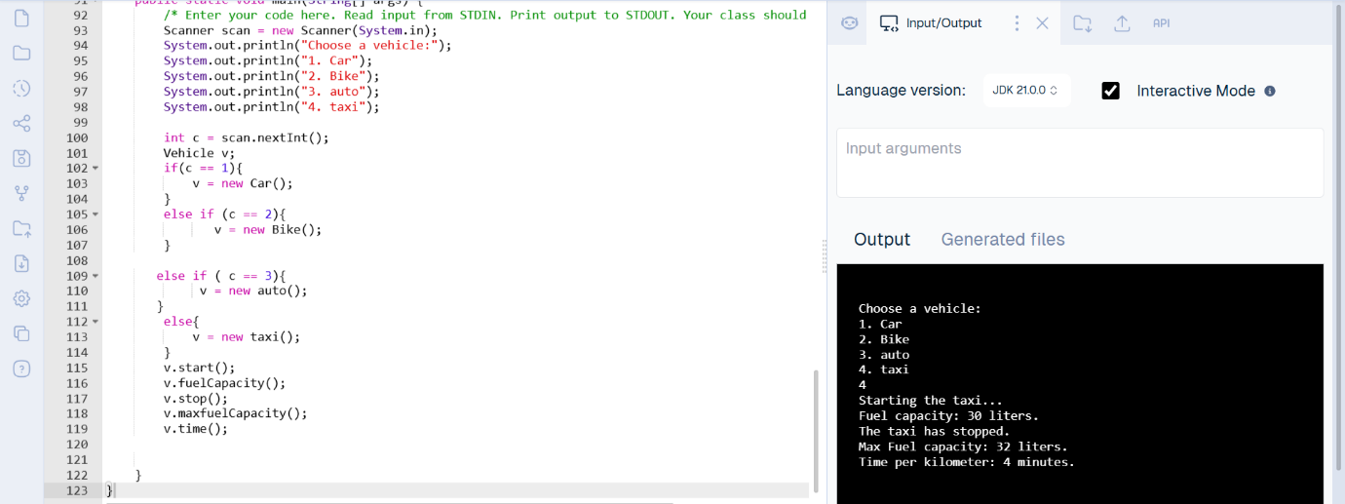

Result
The program was successfully executed. It clearly demonstrates run-time polymorphism using an interface. Different vehicle objects were created and accessed through the parent interface reference, and the appropriate overridden methods were executed based on user input.

